ARCHITECT REVIEW
SCC-3655 | Internal Case Comments
Great Plains Sandboxes | Read-only configuration and UAT readiness assessment
Environments | GreatPlainsMerge 00DEa00000GkAsHMAV | GreatPlainsUAT 00DEa00000FZlLBMA1
Review date | 26 August 2026
Retrieval | Succeeded | Merge 09SEa00000id0hxMAA | UAT 09SEa00000icYhBMAU
Decision | Conditional approval - configuration complete; runtime evidence pending
Boundary | No records, deployment, activation, or org metadata were changed

ARCHITECT DECISION
Do not deploy redundant SCC-3655 metadata. The standard Case Comments configuration is present. Approve runtime behavior only after a named UAT rep completes the two-comment evidence run; Trouble Ticket-specific testing also depends on its separate UAT record type and layout promotion.

Acceptance outcome
# | Scope | Result | Evidence
1 | Internal designation | Config pass | IsPublished is createable and updateable; leave Public/Published unchecked for internal-only comments.
2 | Date and time | Config pass | CreatedDate is a non-editable system datetime field on CaseComment.
3 | Posting user | Config pass | CreatedById is a non-editable system reference that records the posting user.
4 | Lifecycle chronology | Runtime pending | The related list is configured, but both sandboxes currently contain zero CaseComment records.
5 | Rep can post and read | Partial pass | UAT has the related list and 46 active CRC Team users; a named-user UI test was not executed.

Solution and visibility path
SCC-3655 uses only the standard Case Comments related list and CaseComment fields. The configuration path is complete; the remaining gate is persona-level runtime evidence in UAT.
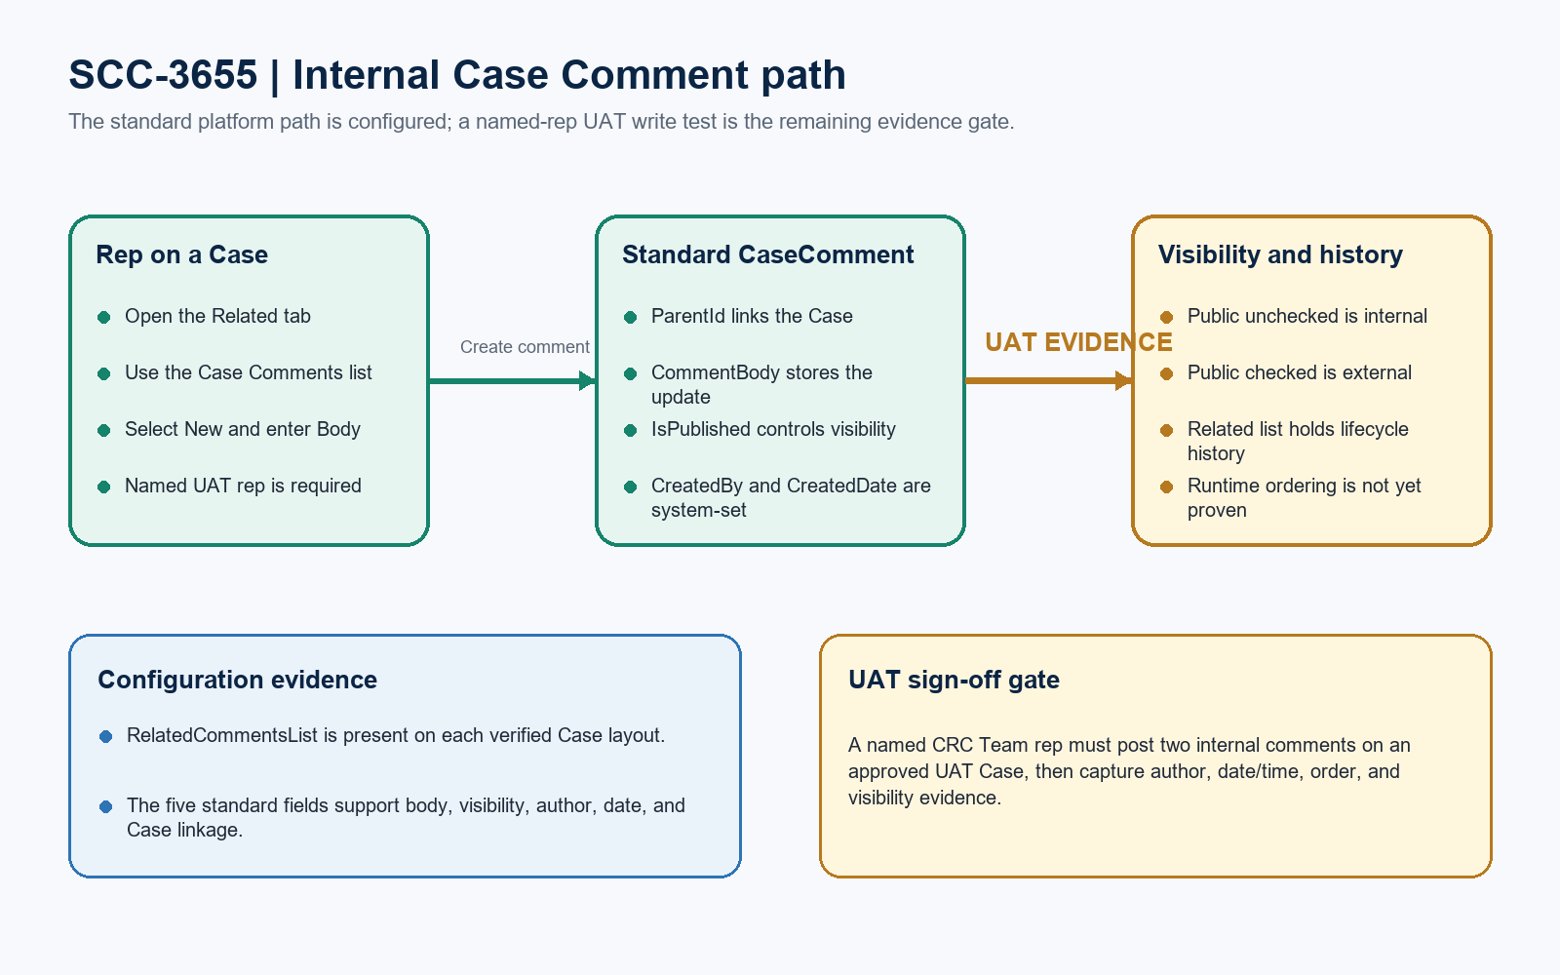
Figure 1. SCC-3655 internal Case Comment path
DESIGN READING
Green is verified platform configuration. Amber is the remaining UAT evidence gate.

Detailed configuration findings

1. Case layout presence
Org | Layout | Result | Evidence
GreatPlainsMerge | Case-Case Layout | Present | RelatedCommentsList is present.
GreatPlainsMerge | Case-Trouble Ticket | Present | RelatedCommentsList is present.
GreatPlainsUAT | Case-Case Layout | Present | RelatedCommentsList is present.
GreatPlainsUAT | Case-Trouble Ticket | Dependency missing | Trouble_Ticket record type and dedicated layout are not yet present.

2. Standard CaseComment behavior
Field | Type | Write behavior | Architect evidence
ParentId | Reference | Createable; required | Links each comment to its Case.
CommentBody | Text area | Createable and updateable | Stores the rep's comment body.
IsPublished | Boolean | Createable and updateable | Unchecked is internal; checked is externally available.
CreatedById | Reference | System-set | Records who posted the comment.
CreatedDate | Date/Time | System-set | Records when the comment was created.

PERSONA EVIDENCE GATE
GreatPlainsUAT has 46 active GPC-Residential CRC Team users. The profile query alone does not prove that the intended rep can post and read Case Comments, so one named-user UI run is required.

Runtime evidence and UAT execution

Read-only evidence boundary
Boundary | Evidence
Metadata retrieved | Three named Case layouts across the two sandboxes; both successful retrievals recorded.
Schema checked | ParentId, CommentBody, IsPublished, CreatedById, and CreatedDate were verified live.
Available UAT Cases | 20 Case records exist in GreatPlainsUAT; no Case record was selected or changed.
Comment baseline | GreatPlainsMerge and GreatPlainsUAT each contain zero CaseComment records.
Org write boundary | No records, metadata, activation, deployment, or check-only deployment were changed or run.

Named-rep UAT runbook
Step | Action | Expected result / evidence
1 | Assign test context | Name one CRC Team rep and approve one UAT Case; record both identifiers.
2 | Post internal comment A | Open Related > Case Comments > New; enter a unique body; leave Public unchecked.
3 | Post internal comment B | Wait at least one minute, then add a second internal comment.
4 | Verify audit trail | Confirm both entries display posting user and Created Date/Time.
5 | Verify lifecycle order | Confirm the two comments appear in a consistent chronological sequence.
6 | Capture sign-off | Save Case number, rep, timestamps, visibility result, ordering result, and screenshots.

Required approval gates
Gate | Required action | Owner | Evidence needed
1 | Name the UAT rep and Case | QA / CRC lead | Provide the approved Case number and the named GPC-Residential CRC Team tester.
2 | Run internal comment test | Named rep | Create two comments with Public unchecked and capture both saved records.
3 | Verify acceptance evidence | QA | Confirm author, Created Date/Time, internal visibility, and chronological order.
4 | Resolve external scope | Product owner | If external comments are in scope, approve a separate Public-checked test and external channel.
5 | Resolve Trouble Ticket dependency | Release manager | Promote the Trouble_Ticket record type and layout separately if SCC-3655 must be tested on that record type.

Ready-to-paste architect response
STORY COMMENT
Architect review completed across GreatPlainsMerge and GreatPlainsUAT. Conditional Approval: SCC-3655 uses standard Salesforce Case Comments, and no SCC-3655-specific deployment is required. RelatedCommentsList is present on the GreatPlainsMerge Case-Case Layout and Case-Trouble Ticket layout and on the GreatPlainsUAT Case-Case Layout. Live schema confirms CommentBody and IsPublished are writable, while CreatedById and CreatedDate are system-set. Both sandboxes currently contain zero CaseComment records, so rep posting, author display, timestamp display, chronological order, and internal/external visibility remain runtime-pending. GreatPlainsUAT has 20 Cases and 46 active GPC-Residential CRC Team users, but no named tester or approved Case was supplied. Complete the five gates above before final story approval. If testing must use a Trouble Ticket, promote that separate record type and layout prerequisite first. No org data, metadata, activation, or deployment changes were made.

